Annex 2: Child Protection Support Documents

The following support documents are provided in the following pages:

Annex 2.a Key Safeguarding Principles
Annex 2.b Guidelines for Schools in Tamil Nadu on Student Safety and Protection from Sexual Violence
Annex 2.c Legal Framework
Annex 2.d Police clearance process for recruitment
Annex 2.e SAIIER Media Consent Form
Annex 2.f Recognising Child Abuse
Annex 2.g Definitions of ‘child in conflict with law’ (CCL) and ‘child in need of care and protection’ (CNCP) according to the Juvenile Justice Act (2015)
Annex 2.h Report form template
Annex 2.i SAIIER Code of conduct (extended for child protection)

2.a Key Safeguarding Principles

- Safety: All possible measures shall be taken to ensure that the child is safe and not subjected to any harm, abuse or maltreatment in the school.
- Best interest of child: All decisions regarding the child are based on the primary consideration of acting in their best interest and ensuring the best possible outcomes for the child.
- Right to privacy and confidentiality: Every child has the right to privacy and confidentiality.
- Equality and non-discrimination: no discrimination against a child on any grounds including: sex, age, caste, religion, ethnicity, place of birth, disability. Equality of access and treatment shall be offered to every child attending Auroville and outreach educational establishments.
- Principle of participation: Every child has a right to be heard and to participate in processes and decisions affecting them. The child’s views are seen with due regard to age and maturity.
- Principle of responsibility: Everyone in the community has a role to play in ensuring safe, healthy and secure environments for children, be it school staff, parents, social services, working groups, concerned residents and children themselves. Everyone has the choice to be an upstander when situations of violence against children arise.

2.b Guidelines for Schools in Tamil Nadu on Student Safety and Protection from Sexual Violence
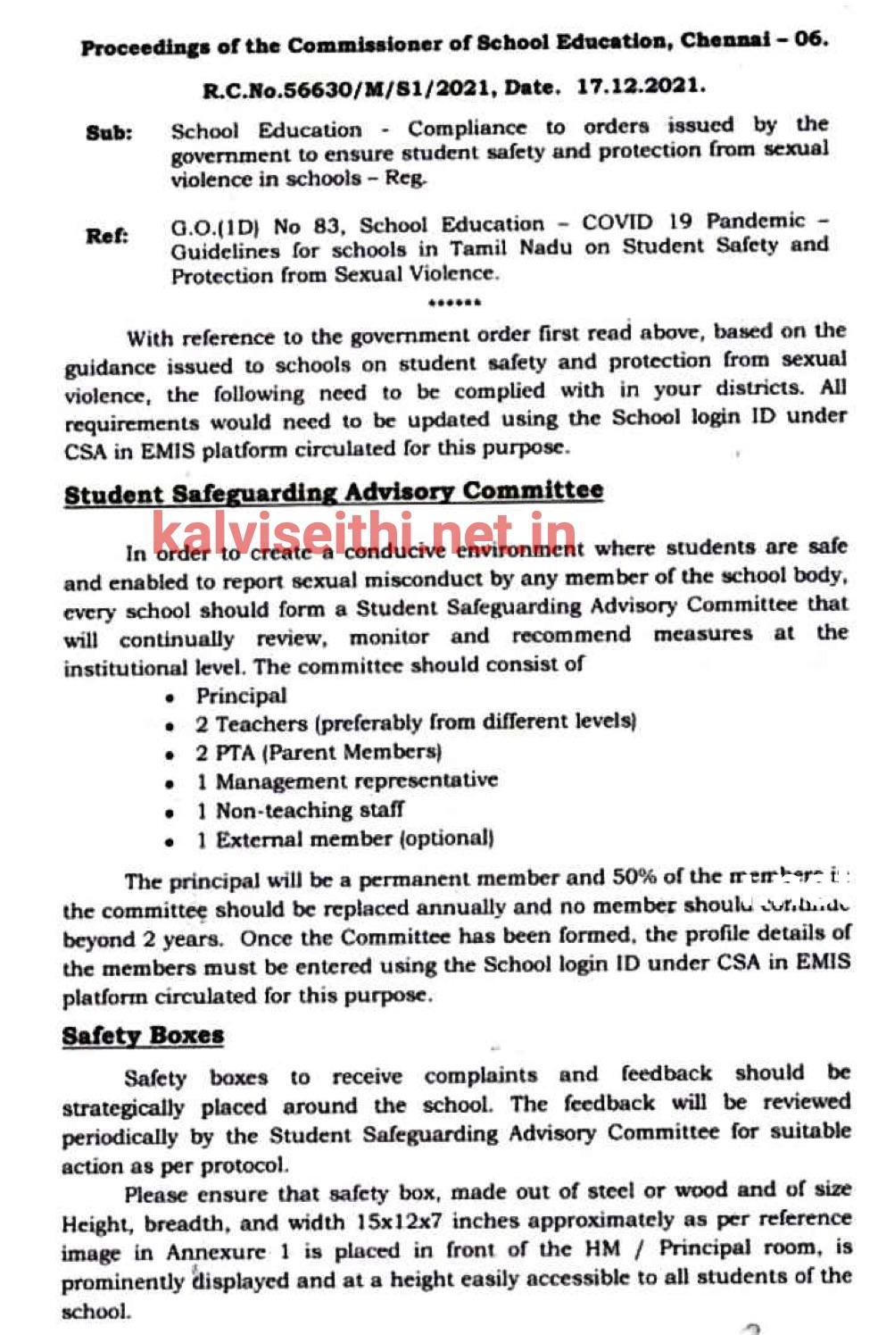
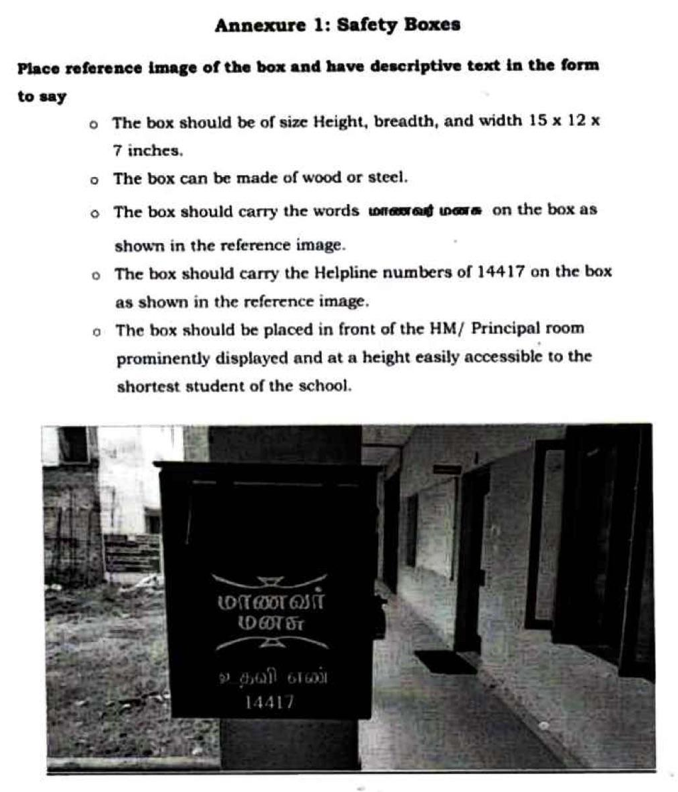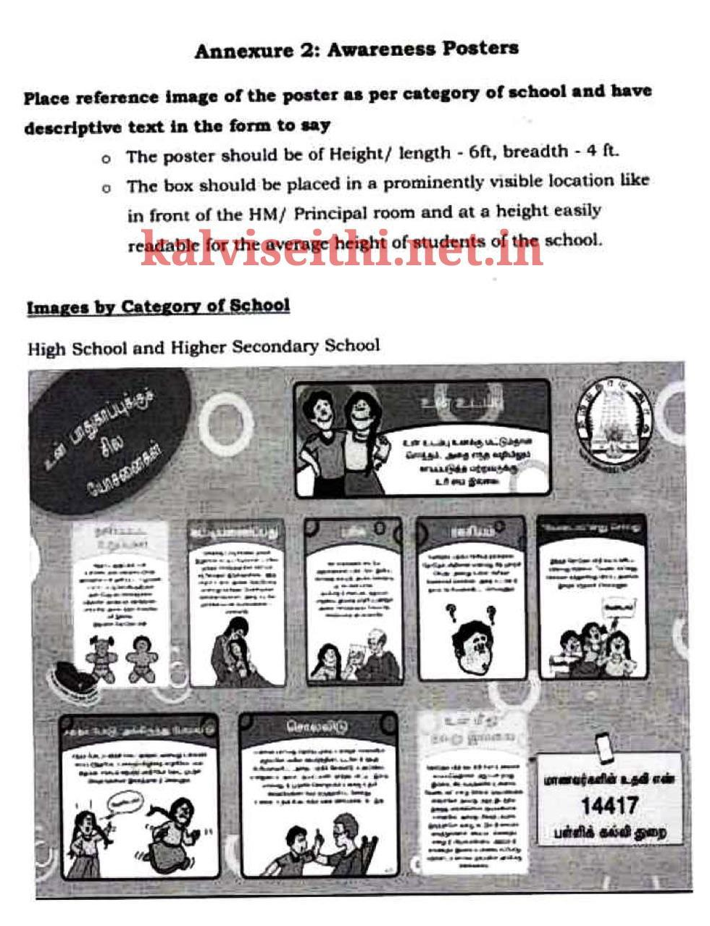
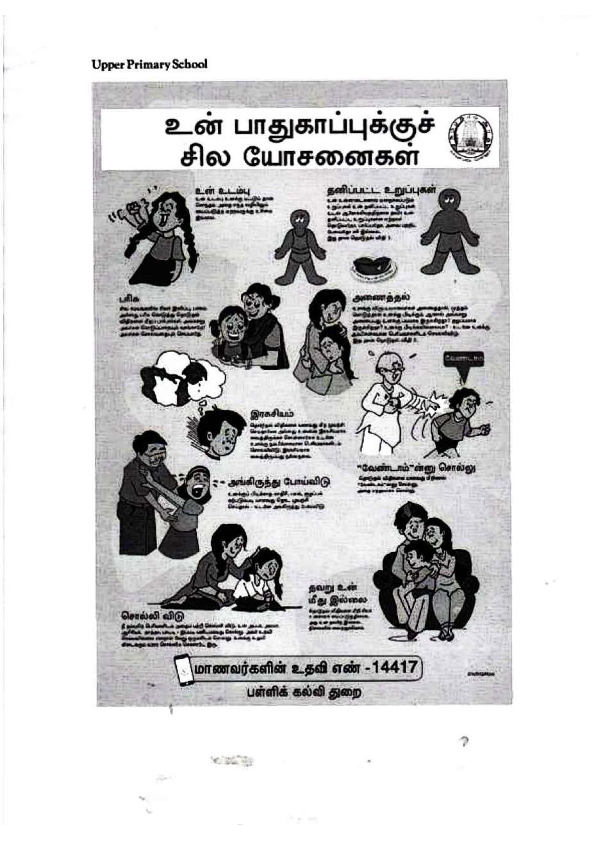

2.c Legal Framework

India’s Legal Framework:
The Constitution of India recognises children as equal rights holders and grants highest priority for their protection and well-being. India is also signatory to the United Nations Convention on the Rights of the Child (UNCRC), 1989 and accordingly has a strong legal framework to protect children, notably including:
CORE NATIONAL CHILD PROTECTION LAW (the list below is not exhaustive)
- The Right to Free and Compulsory Education Act, 2009 (RTE Act, 2009) Notably, this act prohibited the use of corporal punishment, including ‘mental harassment’, in schools. The act also proposes the creation of ‘School Management Committees’ (SMC), consisting of elected representatives, parents and teachers, to: monitor the working of the school; prepare a school development plan; and monitor the use of grants.
- POCSO - Protection of Children from Sexual Offences Act, 2012. The act seeks to protect all children below the age of 18 from sexual assault, sexual harassment and pornography. POSCO represents a landmark of Indian legislation as for the first time in Indian Penal law, all relevant offences are clearly defined and stringent punishment is given to the offenders. Further, in 2019, amendment to the act increased severity of punishment for several categories of abuse. Notably, the act states that it is mandatory that any knowledge or suspicion of sexual offence against a child is reported by any person to the police, Childline (1098) or the local Child Welfare Committee (Villupuram - 04146-241702).
  - POCSO Rules (2020): requires that the Tamil Nadu state government implements:
    - Requirement of a police verification and background check for all school staff (POCSO, 2020: Art.3(4)
    - Requirement of provision of training for teachers and all persons coming in contact with children to sensitise them about child safety and protection and educate them regarding their responsibility under the act (POCSO,2020: Art. 3(6)
    - Each state shall formulate a Child Protection Policy which shall be adopted by all institutions, organizations, or any other agencies working with or coming in contact with children (POCSO,2020: Art.3 (5)).

- The Juvenile Justice Act (Care and Protection of Children) Act, 2015 The act is founded on the principles of the UNCRC, and provides a framework for the care, protection, treatment and rehabilitation of children in the purview of the juvenile justice system. It mandates child protection mechanisms in all districts of the state such as the Child Welfare Committees (CWC), Special Juvenile Police Units (SJPU) and Juvenile Justice Boards (JJB) and State/District Child Protection Units (DCPU). Notably it defines a CNCP “child in need of care and protection” and a CCL “child in conflict with the law” and associated measures of response.

GOVERNMENT GUIDANCE FOR CBSE SCHOOLS
Manual on Safety & Security of children in schools (NCPCR, 2017) - compiles existing and approved guidelines and notably sections on: psycho-social aspects, roles and responsibilities of teachers and monitoring. In the section on monitoring, the manual refers to the roles of the School Management Committees (SMC, are defined in RTE Act, 2009) and the Parent Teacher Associations (PTA) (NCPCR, 2017; p. 65-6).
TAMIL NADU STATE CHILD POLICY
Tamil Nadu State Policy for Children (2021) – notably: ‘The State shall take the necessary steps to introduce child safeguarding policy in all schools to make all schools safe for children’ (p. 16).
TAMIL NADU GOVERNMENT GUIDELINES (June 2021)
Guidelines for Schools in Tamil Nadu on Student Safety and Protection from Sexual Violence (see Annex 2b).

Relevant Auroville Policies:
Auroville Conflict Resolution Policy, 2015
Auroville Entry Policy, 2017
SAIIER Code of Conduct, 2004 (extended for child protection), 2022
Auroville Exit Policy (not ratified by community)

2.d Police clearance process for recruitment

For Indian Nationals
There is a Police Outreach Resource Centre (PORC) in every police station. The individual who needs to get his/her verification needs to approach the PORC. The person fills the form and submits it to the PORC. The fee of this service is around Rs 400.
The concerned police station coordinates with the police station of the place of origin of the individual. They then send the report back to the police station that issued the request. Accordingly, the person will get the clearance certificate from the Station House Officer of the police station.
There is no assigned validity of the police clearance certificate.
According to the police personnel, the entire Indian police force is connected to a central server. Whenever a crime is committed by an individual, the police station of jurisdiction in question will send the report immediately to the police station of the individual’s native place. This ensures that any criminal record of the person is there in the police station which can be tracked or verified while getting the verification done of an individual.
For Foreign Nationals
Obtaining police clearance for adults working with children is standard procedure in many countries. The process for obtaining police clearance varies from country to country and can take months to obtain. It is therefore important that any volunteers or newcomers planning to work with children in Auroville or outreach schools plan in advance and obtain this clearance before coming to Auroville. Therefore, it is important that the school informs these future staff members of this requirement well in advance of coming to Auroville. SAVI as the organisation that helps volunteers who come to Auroville may also provide this information to prospective volunteers.

2.e SAIIER Media Consent Form

SAIIER Multi Media Waiver

I, _____________________________________________
(Print Parent/Guardian Name), hereby agree and give my permission for

_______________________________________________
(Print student name) to be photographed in school and during school events.

The images may be used only for school related purposes and with permission from the school.
For other uses, permission of the parents must be given to the photographer. Images taken in school and during school events will not be used by the photographer on his/her social media or in any other way without express written permission from the parents.

(Please circle): YES / NO.

Date:____________ Signature of Parent/Guardian: ______________________________

2.f Recognising Child Abuse
All staff should be aware of the indicators of abuse and neglect so that they are able to identify cases of children who may be in need of help or protection in school.
Child abuse happens by inflicting harm or by failing to act to prevent harm to any child. Children may be abused by adults or other children, in a family or in an institutional setting (e.g. in the school itself) or in the community, by those known to them or, more rarely, by others. Abuse can take place online, or technology may be used to facilitate offline abuse. In a general sense abuse can be categorised as: physical, emotional or sexual and also includes neglect. These categories, in reality, are overlapping and interdependent.
Physical abuse

A form of abuse which may involve hitting, shaking, throwing, poisoning, burning or scalding, drowning, suffocating or otherwise causing physical harm to a child. Physical harm may also be caused when a parent or carer fabricates the symptoms of, or deliberately induces, illness in a child.

Physical abuse indicators in child:
Bruises – shape, grouping, site, repeat or multiple | Withdrawal from physical contact
Bite-marks – site and size.  Burns and Scalds – shape, definition, size, depth, scars | Aggression towards others, emotional and behavioural problems
Improbable, conflicting explanations for injuries or unexplained injuries | Frequently absent from school
Untreated injuries | Admission of punishment which appears excessive
Injuries on parts of body where accidental injury is unlikely | Fractures
Repeated or multiple injuries | Fabricated or induced illness

Emotional abuse

The persistent emotional maltreatment of a child such as to cause severe and adverse effects on the child’s emotional development. It may involve conveying to a child that they are worthless or unloved, inadequate, or valued only insofar as they meet the needs of another person. It may include not giving the child opportunities to express their views, deliberately silencing them or ‘making fun’ of what they say or how they communicate. It may feature age or developmentally inappropriate expectations being imposed on children. These may include interactions that are beyond a child’s developmental capability as well as overprotection and limitation of exploration and learning or preventing the child from participating in normal social interaction. It may involve seeing or hearing the ill-treatment of another (e.g. domestic violence). It may involve serious bullying (including cyberbullying), causing children frequently to feel frightened or in danger, or the exploitation or corruption of children. Some level of emotional abuse is involved in all types of maltreatment of a child, although it may occur alone.

Emotional abuse indicators in child:
Extremes of passivity or aggression | Makes a disclosure
Chronic running away | Abnormal or indiscriminate attachment
Drug/solvent abuse | Low self-esteem
Compulsive stealing | Self-harm
Over-reaction to mistakes / Inappropriate emotional responses | Social isolation – withdrawn, a ‘loner’. Frozen watchfulness particularly pre school
Developmental delay | Depression
Neurotic behaviour (e.g. rocking, hair twisting, thumb sucking) | Desperate, attention-seeking behaviour

Sexual abuse

Involves forcing or enticing a child or young person to take part in sexual activities, not necessarily involving violence, whether or not the child is aware of what is happening. The activities may involve physical contact, including assault by penetration (for example rape or oral sex) or non-penetrative acts such as masturbation, kissing, rubbing, and touching outside of clothing. They may also include non-contact activities, such as involving children in looking at, or in the production of, sexual images, watching sexual activities, encouraging children to behave in sexually inappropriate ways, or grooming a child in preparation for abuse. Sexual abuse can take place online, and technology can be used to facilitate offline abuse. Sexual abuse is not solely perpetrated by adult males. Women can also commit acts of sexual abuse, as can other children. The sexual abuse of children by other children is a specific safeguarding issue (also known as peer-on-peer abuse) in education and all staff should be aware of it and of their school or colleges policy and procedures for dealing with it.

Sexual abuse indicators in child:
Pregnancy | Poor self-image, self-harm, self-hatred
Running away from home | Inappropriate sexualised behaviour
Reluctant to undress for sports | Withdrawal, isolation or excessive worrying
Self-harm - eating disorders, self-mutilation and suicide attempts | Sexual knowledge or behaviour inappropriate to age/stage of development, or that is unusually explicit
Inexplicable changes in behaviour, such as becoming aggressive or withdrawn | Poor attention/concentration (world of their own)
Pain, bleeding, bruising or itching in genital and/or anal area | Sudden changes in schoolwork habits, e.g. not attending school
Sexually exploited or indiscriminate choice of sexual partners

Neglect

The persistent failure to meet a child’s basic physical and/or psychological needs, likely to result in the serious impairment of the child’s health or development. Neglect may occur during pregnancy, for example, as a result of maternal substance abuse. Once a child is born, neglect may involve a parent or carer failing to: provide adequate food, clothing and shelter (including exclusion from home or abandonment); protect a child from physical and emotional harm or danger; ensure adequate supervision (including the use of inadequate care-givers); or ensure access to appropriate medical care or treatment. It may also include neglect of, or unresponsiveness to, a child’s basic emotional needs.

Neglect indicators in child:
Failure to thrive - underweight, small stature  Dirty and unkempt condition | Low self-esteem  Inadequate social skills and poor socialisation
Inadequately clothed | Frequent lateness or non-attendance at school
Dry sparse hair | Abnormal voracious appetite at school or nursery
Untreated medical problems | Self-harming behaviour
Red/purple mottled skin, particularly on the hands and feet, seen in the winter due to cold | Constant tiredness
Swollen limbs with sores that are slow to heal, usually associated with cold injury | Disturbed peer relationships

2.g Definitions of ‘child in conflict with law’ (CCL) and ‘child in need of care and protection’ (CNCP) according to the Juvenile Justice Act (2015)

Child in conflict with law: means a child who is alleged or found to have committed an
offence and who has not completed eighteen years of age on the date of commission of such offence;
Child in need of care and protection: a child -
(i) who is found without any home or settled place of abode and without any ostensible means of subsistence; or
(ii) who is found working in contravention of labour laws for the time being in force or is found begging, or living on the street; or
(iii) who resides with a person (whether a guardian of the child or not) and such person—
(a) has injured, exploited, abused or neglected the child or has violated any other law for the time being in force meant for the protection of child; or
(b) has threatened to kill, injure, exploit or abuse the child and there is a reasonable likelihood of the threat being carried out; or
(c) has killed, abused, neglected or exploited some other child or children and there is a reasonable likelihood of the child in question being killed, abused, exploited or neglected by that person; or
(iv) who is mentally ill or mentally or physically challenged or suffering from terminal or incurable disease, having no one to support or look after or having parents or guardians unfit to take care, if found so by the Board or the Committee; or
(v) who has a parent or guardian and such parent or guardian is found to be unfit or incapacitated, by the Committee or the Board, to care for and protect the safety and well-being of the child; or
(vi) who does not have parents and no one is willing to take care of, or whose parents have abandoned or surrendered him; or
(vii) who is missing or run away child, or whose parents cannot be found after making reasonable inquiry in such manner as may be prescribed; or
(viii) who has been or is being or is likely to be abused, tortured or exploited for the purpose of sexual abuse or illegal acts; or
(ix) who is found vulnerable and is likely to be inducted into drug abuse or trafficking; or
(x) who is being or is likely to be abused for unconscionable gains; or
(xi) who is victim of or affected by any armed conflict, civil unrest or natural calamity; or
(xii) who is at imminent risk of marriage before attaining the age of marriage and whose parents, family members, guardian and any other persons are likely to be responsible for solemnisation of such marriage.

2.h Report form template

STANDARD REPORT FORM OF CONCERN FOR CHILD SAFETY

Name of staff filling this form: ______________________________ Date:________________________

Person providing report | Date concern shared:
Person providing report | Name:
Person providing report | Contact details: (email, phone, community)
Student victim(s) | Name(s) |  | Date of birth
Student victim(s) | School name and class |  | Male/female:
Student victim(s) | Type of abuse: | Physical  Emotional | Sexual  Neglect
Student victim(s) | Contact details:  (email, phone, community)
Involved parties | Suspect’s name and contact details. (email, phone, community) |  | Relationship of suspect to victim:
Involved parties | Victim’s parents names, email, phone, community (if different from child)
Involved parties | Other parties and/or relevant info
Incident information | Date of incident: |  | Location of incident:
Incident information | Narrative description of incident(s) | What the reporter observed, what was said, etc. Descriptions of behaviour and facts. Use another paper if needed.

2.g SAIIER code of conduct
SAIIER

Code of Conduct (Including Child protection 5 pages)

The aim of education in Auroville is to offer an integral education centered around the awakening of the psychic being, the perfecting of the mental, vital and physical natures, and an opening to spiritual consciousness, so that people from different cultural and ethnic backgrounds can grow together in an atmosphere of protected freedom and harmony, and feel that we are citizens of one world, aspiring to manifest a truer and higher life on earth.

Part of the way toward achieving this aim is for the teachers and other people who work in the Auroville schools to maintain a code of conduct that is consonant with the ideals expressed. The code of conduct below is not a comprehensive listing of what we should and should not do. The code of conduct is meant as a guideline to help us while we are still developing our own abilities to "manifest a truer and higher life".

- Education in Auroville Schools is child-centered and value oriented. The schools should communicate with parents on a regular basis to fully understand the child and to encourage a complete educational process (i.e., education does not only happen at school).
- All Aurovilians and Newcomers working in the Auroville schools should understand the aims of education in Auroville. All are expected to:
- Teach in a manner that promotes the overall aims of Auroville as expressed in the Charter
- Abide by all school policies
- Good teachers are good adult role models. Teachers are expected to:
- Maintain high standards of personal behaviour, including the display of temperate behaviour at all times and in all places.
- Ensure that the student-teacher relationship is not used for personal gain or any other purpose that is not in the students’ best interests.
- Not engage in any illegal activities.
- Refrain from using alcohol and tobacco on the school campuses.
- The student-teacher relationship should be based on trust and mutual respect. To develop this we must:
- Treat and speak to all students with dignity and respect and remember that students have many factors that affect their lives.
- Be considerate of the students' circumstances.
- Maintain strict confidentiality in relation to any discussions and decisions about parents and students at school.
- Auroville schools should aspire to help individual students achieve their full potential. In order to do this we must:
- Promote a safe and appropriate learning environment
- Strive to use positive teaching methods.
- Amorous and/or sexual relationships of any kind between students and teachers or other members of the school staff are prohibited both inside and outside of school.
- Teachers should not socialize privately on a one-on-one basis with students without the presence of another adult.
- Excessive and indiscriminate displays of physical affection are strongly discouraged as this can result in misunderstanding and confusion.
- Humiliation and physical punishment are not allowed.
- Staff members who have difficult problems that they are unable to solve should bring them at the school meetings.

- Teachers who cannot come to scheduled classes for valid reasons should inform the school in a timely manner, whenever possible, so that a substitute may be found. Teachers should be on time for classes. If, by any chance, a teacher is going to be late for class the school should be informed.

SAIIER code of conduct continued…
In the SAIIER code of conduct, the broad context of engagement of teachers and adults with children in the schools has been indicated. The Auroville Child Protection code of conduct that follows, provides a more detailed list of points relating to behavioural conduct.
A culture of wellbeing for every child
We want a culture with children which is based of responsibility and inner guidance rather than compliance or free licence, where teachers shift from being confused or fearful when an incident occurs to being able to recognize, support and prevent child abuse and provide a safe, secure space for every child in the school to stretch and grow.
A code of conduct, signed by all staff members, is only a first step to providing guidance for the above. The subsequent step being to develop a broader child protection policy at each school.
A message to a teacher by The Mother:
‘....you are a good teacher but it is your way of dealing with the children that is objectionable. The children must be educated in an atmosphere of love and gentleness. No violence, never. No scolding, never. Always a gentle kindness and the teacher must be the living example of the virtues the child must acquire….. All that depends exclusively on the teacher. What he does and how he behaves’. The Mother - On Education - p194.
Legal Responsibility
POCSO (Protection of children against Sexual Offences) rules of 2020 require that the state governments implement:
- Requirement of a police verification and background check for all school staff (POCSO, 2020: Art.3(4)
- Requirement of provision of training for teachers and all persons coming in contact with children to sensitize them about child safety and protection and educate them regarding their responsibility under the act (POCSO,2020:Art. 3(6))
- Child Protection Policy which shall be adopted by all institutions, organizations, or any other agencies working with or coming in contact with children (POCSO,2020: Art.3 (5)). The Tamil Nadu State Child Policy was released in 2021.

SAIIER code of conduct to safeguard children
Scope of code
  - Children are defined as any person under the age of 18 years.
  - Staff are all adults who work with children in Auroville and outreach educational establishments, irrespective of status or title (volunteer, guest, visiting faculty, newcomer, Aurovillian).
  - This code of conduct sets out a policy for all staff in the context of work within the educational establishment (school, after-school club, sports club, boarding house, cultural centers) and is a central part of the wider safeguarding system for children in Auroville.
  - Certain issues such as peer-on-peer abuse or bullying (including online) are managed within the school and should already form part of existing school policy. The present code of conduct is complementary to any existing school agreements or policy .
Code of conduct
Safeguarding and promoting the welfare of children is everyone’s responsibility; everyone who comes into contact with children and their families has a role to play.
As a professional member of staff and a role-model to children, I will:
  - Maintain high standards of personal conduct, including the display of moderate behaviour at all times and in all places.
  - Be mindful about the perception and appearance of language, actions and relationships with children, taking into account the cultural context (e.g. dressing appropriately, respectful communication).
  - Consider myself responsible, regardless of the child’s behaviour.
  - Ensure that my approach is child-centred. This means that I will consider at all times, what is in the best interest of the child.
  - Avoid spending excessive time alone with children away from others or engaging in communication beyond that appropriate in the teacher-student relationship (e.g. texting, social media, calls, video conferencing).
  - Follow the ‘two adult’ rule on school trips, wherein two or more adults are with children to ensure sufficient supervision.
  - Recognise that some children are more vulnerable to harm (including online), owing to challenging life circumstances, having special educational needs and/or disabilities. I will report these cases to the relevant school management and ask for support or training.
  - Observe and comply with any agreements, rules or policies specified by the school, the Auroville community and the Indian law.
I will under no circumstances:
- Act in ways intended to shame, humiliate, belittle or degrade children or engage in any other form of emotional abuse or mental harassment.
- Engage in any form of physical punishment (e.g. hitting, kicking, pushing, pinching, pulling on the ear, pushing hard or pulling on the arm).
- Fondle, hold, kiss, hug or touch children in an inappropriate or culturally insensitive way. To avoid misunderstanding it is recommended to ask the child’s permission before touching or holding hands.
- Engage in any form of sexual relationship with children, including the use of pornography or inappriate images, regardless of the child’s age and behaviour. Mistaken belief in the age of a child is not an excuse.
- Discriminate against particular children in relation to family status, caste, class, race, nationality, religion or gender.
I will empower children by:
  - Contributing to the provision of a safe and caring environment in which children grow towards their full potential.
  - Treating and speaking to all children with dignity and respect and being considerate of each child’s circumstances.
  - Not doing things for children that they can do for themselves. For example, letting them go to the toilet alone, get dressed alone, eat without help, clean up after their work.
  - In disciplinary issues, involving the child in reflection, self-awareness and understanding of the consequences of their actions and corrective/supportive measures.
  - In cases where the child may have been abused, to support them through a process that builds resilience.
  - Ensuring that children are apprised of their rights (see United Nations Convention of the Rights of the Child), provided with prospects to engage in issues of concern to them, build on their aspirations and express their views in accordance with age, maturity and capacities.
  - Putting in place systems for children to express their views and give feedback and being involved in the process of their education.
  - Providing children with a platform to express their opinions and needs and notably to report any abuse, in confidentiality.
I will respond to any suspected cases of child abuse by:
- Taking any report of abuse seriously by listening with care and neutrality (without judgement or blame).
- Immediately reporting to the school safeguarding lead (SGL) or relevant school staff in accordance with an agreed school referral procedure or to SAIIER executives if these are not in place.
- Support the relevant bodies (e.g. Auroville Council, Working Committee, SAIIER, AVCP, police, Childline, Child Welfare Committee) in following up with the case.

Signed by: _____________________________ Date: _____________________________

